

Computing and Artificial Intelligence Cluster
Capstone Project Workbook



Campus | BNY – Girls ATS
Supervisor | MS. Dina Sarris
Capstone Project Title | SANAD AI CRISIS AND SAFETY ASSISTANT
Group Student Names | Alreem Tareq, Dhabya Mohsin, Mahra Asaad, Sara Nasser

Table of Contents
Section1- Grade 11 3
G11 Term 3 – Project Overview 4
G11 Term 3- Project Planning and Proposal Phase 4
G11 Learner Evidence 7
Section2- Grade 12 31
G12 Term 1 overview 32
G12 Term 1- Project Implementation Phase 32
G12 Learner evidence 34
Appendix 35
Appendix A- Recommended Technology Resources 35
Appendix B- Suggested Hardware Component 37
Appendix C- Suggested AI tools & Technology Stack 38

Section1- Grade 11



G11 Term 3 – Project Overview

The CAI Capstone Project gives you the opportunity to apply the skills and knowledge you have learned at ATS to solve a real-world problem using AI technologies. You will design, develop, test, and improve a digital or AI-based solution while demonstrating creativity, problem-solving, and technical skills.
Throughout the project, you will plan your work, document your progress, and collaborate with your team, similar to how professionals work in technology fields. The project encourages innovation and the use of modern AI tools and technologies to create a high-quality final product.
Outstanding projects may be showcased at the school’s TVET event. This capstone project is your chance to demonstrate your readiness for future studies and careers in computing and AI while creating a project you can participate in multiple showcase competitions and innovation awards.

G11 Term 3- Project Planning and Proposal Phase
Term 3 Weekly Plan: Project Planning and Proposal
This term, you will start planning your Capstone Project, which you will fully implement and complete in Grade 12, Term 1.
You will explore project ideas, investigate different technical approaches, and develop a clear concept that is both practical and innovative. You will work like a professional AI /Software engineer, considering the end-user and market need in your plan while exploring the recent AI tools and technologies for optimal utilization in your project. This ensures your ideas are realistic, well-organized, and ready to be brought to life.
By the end of week two, you will create a complete project proposal. This proposal will explain what you plan to build, why it is important, and how you will carry it out. It will be submitted to the ATS Directorate CDU Specialist for review and approval. Once approved, your proposal will guide all your planning and practical work in Grade 12, Term 1, helping you stay focused and on track to produce a high-quality project.

Week 1–2: Explore and Select Project Concept
Form a project group of no more than four students, ensuring members demonstrate strong communication skills, teamwork, responsibility, time management, problem-solving ability, and commitment, as these soft skills are essential for successful project completion.
- Brainstorm multiple project ideas with guidance from your supervisor teacher.
- Conduct preliminary research to understand real-world applications and existing solutions.
- Discuss ideas with peers and your supervisor to get feedback and advice.
- Select one project idea to develop further.
- Define the project’s goal, purpose, expected outcomes, and the problem it aims to solve, with supervisor input.
Week 3–5: Prepare and Submit Project Proposal
- Conduct research on software, tools, technologies, GenAI & Agentic AI principles relevant to your project.
- Develop a detailed project proposal under the guidance of your supervisor, including:
  - Project title and description
  - Problem statement
  - Background research
  - Project scope
  - Platforms, AI tools, software and any resources required
  - Expected outcomes
- Submit the completed proposal to the Computing CDU Specialist by the end of Week 4–5.
- Ensure your supervisor reviews your proposal before submission for accuracy and completeness.

QR CODE

Project proposal submissions guidelines
- All team members must actively participate in planning and development tasks under the guidance of the supervisor.
- The supervisor must review and approve the project work before any official submission or progression.
Only one project submission is required per group, representing the collective work of the team.

Week 6–7: Feedback and Revision
- Receive feedback and suggestions from the CDU Specialist.
- Discuss the feedback with your supervisor to understand required changes.
- Revise your project plan, work flow chart, or timeline accordingly.
- Finalize the approved proposal under supervisor guidance to ensure it is realistic and well-structured for pre-production work.
Week 8–End of Term: Project Planning and Pre-Development
Begin detailed pre-development planning with supervisor support:
- Develop system designs, wireframes, flowcharts, or hardware architecture diagrams.
- Create UI/UX stryboard or interface designs where applicable.
- Design algorithms, data flow diagrams, or AI model structures.
- Identify required software, datasets, tools, platforms, and resources.
- Set up development environments and start preliminary coding or prototyping under supervisor guidance.
- Document all planning, designs, decisions, and progress clearly.
- Develop a Gantt chart to visualize the full project timeline, including:
• Planning, development, testing, and deployment milestones
• Key deadlines and supervisor check-ins to monitor progress
- All work in Term 3 focuses on planning and preparation. Full development, testing, documentation, and final presentation will continue in Grade 12, Term 1.

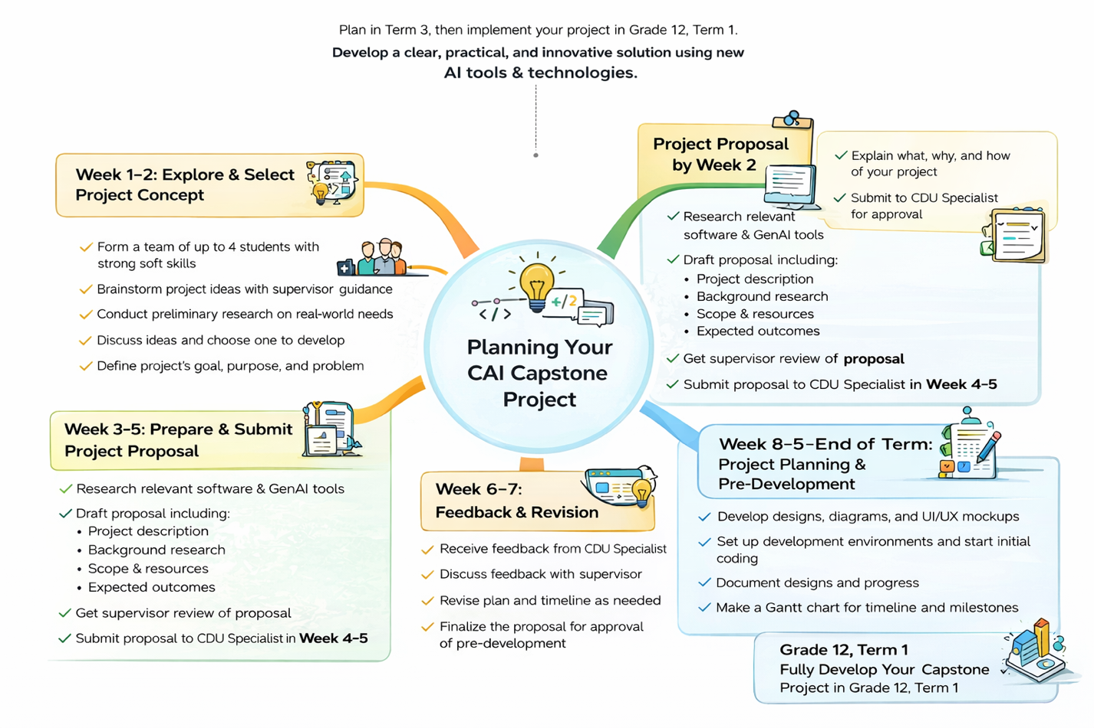

G11 Learner Evidence
Learner evidence  Week 1-2 | First Idea:  SANAD AI Crisis and Safety Assistant  Project Description:  SANAD AI Crisis and Safety Assistant is an AI-powered mobile application designed to help individuals make safe and informed decisions during emergency situations. The system focuses on different types of crises, including armed conflicts, natural disasters such as floods, earthquakes, and storms, as well as public health emergencies and disease outbreaks.  The application uses artificial intelligence to analyze crisis-related information from various sources, evaluate its credibility, classify potential risks, and provide users with clear and structured safety recommendations. SANAD also highlights trusted and verified information sources, helping users avoid misinformation and make better decisions during critical situations.  The system includes an emergency mode that provides quick guidance during urgent events and offers recommendations based on the user's general context, such as their role and approximate location, while maintaining privacy and avoiding precise location tracking.  Project Goal:  The goal of this project is to develop an AI-powered crisis and safety assistant that helps users identify trustworthy information, understand risks, and make safer decisions during emergencies. The system aims to reduce the impact of misinformation and improve public awareness and preparedness during crisis situations.  Project Purpose:  The purpose of this project is to provide people with a reliable and intelligent tool that supports decision-making during emergencies. By combining credibility assessment, risk classification, and safety recommendations into one platform, SANAD helps users understand crisis-related information and respond appropriately. The project also aims to improve access to trusted information while reducing confusion and panic caused by misinformation.  Problems the Project Aims to Solve:  This project addresses the growing problem of misinformation spreading rapidly during crises and emergencies. People often struggle to determine whether information is accurate, which can lead to confusion, fear, delayed responses, or unsafe decisions. Existing systems typically provide updates and alerts but do not evaluate information credibility or provide personalized safety guidance.  SANAD aims to solve these issues by automatically assessing the reliability of information, identifying potential risks, and providing users with clear recommendations based on the situation. This helps individuals make more informed and safer decisions during emergencies.  Expected Outcomes:  The project is expected to deliver a functional AI-powered mobile application available on both Android and iOS platforms. The system will be capable of analyzing crisis-related information, identifying misinformation, classifying risk levels, and generating clear safety recommendations for users.  The application will include an emergency mode for urgent situations, provide access to trusted information sources, and offer a user-friendly interface designed for quick access during crises. Additionally, the project will demonstrate how artificial intelligence can be used to support public safety, improve crisis awareness, and help individuals respond more effectively during emergency situations.  supervisor input:  ( Waiting for the supervisor input )
  Team Members | Roles
  Mahra Asaad | UI/UX Designer (wireframes, layout, user interface design)
  Dhabya Mohsin | Backend Developer (Flask/Django, system integration, APIs)
  Sara Nasser | AI & Data Specialist (NLP, model training, data processing)
  Alreem Tareq | Frontend Developer (HTML, CSS, JavaScript, user interaction)
Learner evidence  Week 3-5 | SANAD AI Crisis and Safety Assistant – Project Proposal  Project Title:  SANAD AI Crisis and Safety Assistant  Project Description:  SANAD AI Crisis and Safety Assistant is an intelligent mobile application designed to help people make safe and informed decisions during emergency situations. The application supports different types of crises, including armed conflicts, natural disasters such as floods, earthquakes, and storms, as well as public health emergencies.  The system uses artificial intelligence to analyze crisis-related information, assess its credibility, identify potential risks, and provide clear safety recommendations. It also highlights trusted and verified information sources to help users avoid misinformation and make better decisions during emergencies.  The main purpose of this project is to reduce the impact of misinformation, improve public awareness, and support safer responses during crisis situations through an easy-to-use mobile application.  Problem Statement:  During emergencies and crisis situations, people often receive information from multiple sources such as social media, messaging applications, and news platforms. Unfortunately, a large amount of this information may be inaccurate, misleading, or outdated.  This creates confusion, panic, and unsafe decision-making. Many individuals struggle to determine which information is trustworthy and what actions they should take to stay safe.  Current information platforms mainly provide updates and alerts but do not evaluate information credibility or offer personalized guidance based on the user's situation.  This project addresses the need for a reliable AI-powered assistant that can assess information credibility, classify risks, and provide clear recommendations to help users make safer and more informed decisions during emergencies.  Background Research:  Many existing solutions provide crisis-related information, including government emergency alerts, news websites, disaster management platforms, and social media networks.  Examples of existing solutions:  - Government emergency notification systems  - News platforms providing real-time crisis updates  - Social media platforms used for information sharing during emergencies  Limitations of Existing Systems:  - Do not assess the credibility of shared information  - Often spread misinformation alongside accurate information  - Provide information but not personalized safety recommendations  - Lack risk classification and decision-support features  How Our Project is Different and Better:  - Evaluates the credibility of crisis-related information  - Identifies and classifies potential risks  - Provides structured safety recommendations  - Includes an emergency mode for quick guidance  - Highlights trusted and verified information sources  - Delivers recommendations based on the user's context  Estimated Development Time:  Approximately 3–5 weeks  Development activities include:  - Research and dataset preparation  - AI model integration and testing  - Mobile application development using Flutter  - User interface design  - System testing and evaluation  This project provides a practical solution that combines information verification, risk assessment, and safety guidance within a single mobile application.  Project Scope:  What the Project Will Include:  - AI-based analysis of crisis-related information  - Credibility assessment of information sources  - Risk identification and classification  - Clear safety recommendations for users  - Emergency mode for urgent situations  - Access to trusted and verified information sources  - Mobile application for Android and iOS  Key Features:  - Information Credibility Checker  - Risk Level Assessment  - Safety Recommendation Engine  - Emergency Guidance Mode  - Trusted Source Verification  What the Project Will NOT Include:  - Replacing official emergency services  - Real-time emergency dispatch services  - Direct communication with police, ambulance, or rescue teams  - Precise location tracking of users  - Professional medical, legal, or emergency advice  Limitations:  - Performance depends on available and updated information  - AI may occasionally misclassify information  - Internet connection is required  - Recommendations are supportive and informational only  - Accuracy cannot be guaranteed in rapidly changing situations  Platforms, AI Tools, Software, and Resources:  This project will be developed using mobile development frameworks, AI technologies, and cloud services. Development and testing will be performed using modern software tools to ensure efficient implementation.  Mobile Platform:  - Cross-platform Mobile Application (Android & iOS)  Programming Languages:  Python  - Used for AI processing, machine learning models, and backend logic.  Dart  - Used with Flutter to build the mobile application.  JavaScript  - Used for additional frontend or web-related functionality if required.  AI and Machine Learning Tools:  Natural Language Processing (NLP) Libraries  - Used to analyze crisis-related text and identify important information.  Machine Learning Frameworks  - Used for credibility assessment and risk classification.  Pre-trained AI Models  - Used to analyze and classify crisis information efficiently.  TensorFlow Lite  - Used to deploy lightweight AI models on mobile devices.  Firebase ML Kit (Optional)  - Used for additional AI functionalities and model integration.  Mobile Development Tools:  Flutter SDK  - Used to develop Android and iOS applications from a single codebase.  Android Studio  - Used for Android development, emulation, and testing.  Xcode  - Used for iOS testing and deployment when required.  Visual Studio Code  - Main development environment for coding and debugging.  Git & GitHub  - Used for version control and project collaboration.  Backend and Cloud Services:  Flask or Django  - Used for backend processing and AI service integration.  Firebase  - Used for authentication, cloud database, and real-time data storage.  Cloud Services  - Used for hosting AI models and backend APIs.  Hardware Requirements:  - Personal laptop or computer for development  - Android smartphone for testing  - Optional iPhone for iOS testing  - Optional Mac device for full iOS deployment  Datasets:  - Public crisis and disaster datasets  - Public health alert datasets  - Conflict and emergency information datasets  - Verified news and trusted information sources  - Misinformation detection datasets  - Sample datasets for model training and evaluation  Summary of Resources:  The project uses widely available development tools, AI frameworks, and cloud services. The combination of Flutter, Python, and machine learning technologies enables the creation of a practical, cost-effective, and scalable mobile safety assistant.  Expected Outcomes:  The project will deliver a functional prototype of an AI-powered crisis and safety assistant that:  - Analyzes crisis-related information  - Detects misinformation and credibility levels  - Identifies potential risks  - Provides structured safety recommendations  - Supports users in making safer decisions during emergencies  It Will Also Include:  - A functional Android and iOS mobile application  - Emergency guidance interface  - Information credibility assessment feature  - Risk classification system  - User-friendly mobile interface  - Project documentation and technical report  Overall Outcome:  The SANAD AI Crisis and Safety Assistant will provide a practical solution that helps reduce the spread and impact of misinformation during emergencies while supporting safer and more informed decision-making for individuals facing crisis situations.
Learner evidence  Week 8-End of Term | 1. Project Overview  Project Description:  SANAD is an AI-powered crisis and safety assistant designed to support individuals during emergency situations. The system analyzes crisis-related information, evaluates its credibility, identifies potential risks, and provides structured safety recommendations. It aims to reduce the spread and impact of misinformation while helping users make informed and safe decisions during emergencies such as armed conflicts, natural disasters, and public health crises.  Project Objectives:  • Develop a mobile application that analyzes crisis-related information using artificial intelligence  • Detect misinformation and evaluate the credibility of information sources  • Classify crisis situations into different risk levels (Low, Medium, High)  • Provide clear and easy-to-understand safety recommendations  • Create a fast and user-friendly interface suitable for emergency situations  • Improve public awareness and support better decision-making during crises  2. System Design  System Architecture / Design:  The SANAD system follows a mobile client-server architecture.  Users interact with the application through a mobile interface, while the backend processes crisis-related information, performs AI analysis, and generates safety recommendations.  The architecture includes:  Mobile Application (Client Side):  User interface where users enter information and receive safety recommendations.  Backend Server:  Handles AI processing, credibility analysis, risk classification, and recommendation generation.  Database:  Stores user requests, crisis information, and system data.  AI Processing Module:  Performs Natural Language Processing (NLP), misinformation detection, and risk assessment.  This design ensures efficient processing, secure data management, and accessibility across Android and iOS devices.  Flowchart / Diagram:  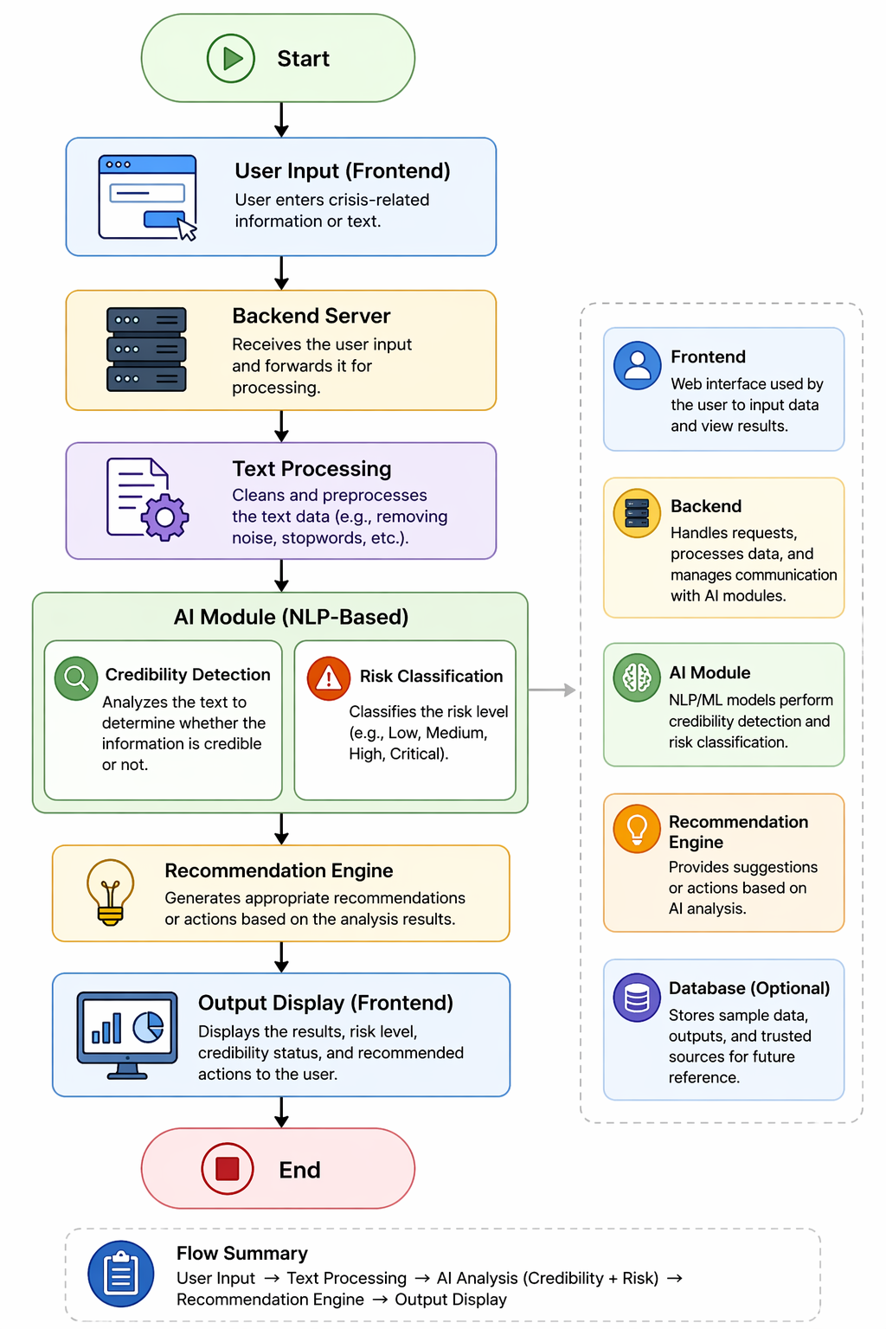  Hardware / Software Architecture:  Hardware:  • Personal computer or laptop for development  • Android device for testing  • iPhone device for testing (optional)  • Internet connection for cloud services and data access  Software:  • Flutter SDK  • Python  • Dart  • Visual Studio Code  • Android Studio  • Xcode (optional)  • Firebase  • Git & GitHub  • NLP and Machine Learning libraries  3. UI/UX Design  Interface Description:  The SANAD interface is designed to be simple, fast, and user-friendly, especially during emergency situations where quick decision-making is important.  Main features include:  • A welcome screen displaying the question:  "What type of emergency are you facing?"  • A text input area for entering crisis-related information  • A "Check Safety" button to analyze the entered content  • Three emergency category buttons:  Conflict / War  • Air raids  • Missile alerts  • Armed conflicts  • Security threats  Natural Disasters  • Floods  • Storms  • Sandstorms  • Earthquakes  Health Crisis  • Pandemics  • Disease outbreaks  • Lockdowns  • Public health warnings  • Skip General Mode button allowing users to continue without selecting a category  The system focuses on:  • Easy navigation  • Fast interaction during emergencies  • Clear categorization of crisis situations  • Accessibility through large buttons and readable text  • Color coding for risk levels and alerts  • Stress reduction through a clean and organized interface  Wireframes / Storyboard:  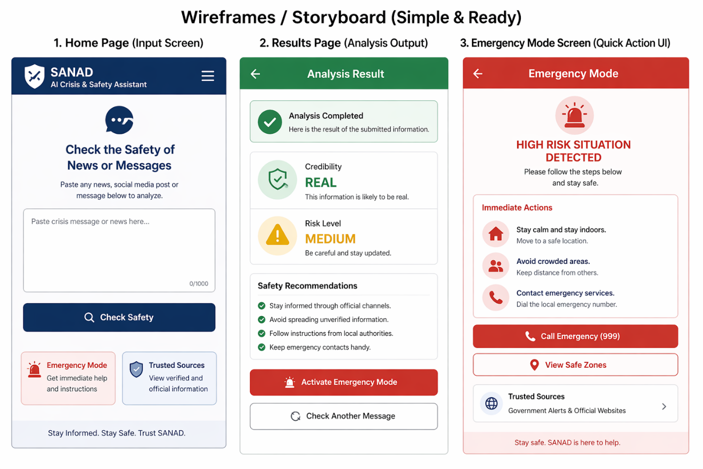  4. Algorithm / AI Model Design  Algorithm Description:  The SANAD system operates using a Natural Language Processing (NLP) and Machine Learning-based classification algorithm.  First, the user enters crisis-related information into the application. The text is then preprocessed by removing unnecessary symbols, stop words, and formatting inconsistencies.  After preprocessing, NLP techniques are applied to extract meaningful features such as keywords, phrases, and contextual patterns. These features are passed to a machine learning model trained to identify misinformation and assess information credibility.  The system then analyzes the content to classify the level of risk as Low, Medium, or High based on detected threats, urgency indicators, and crisis-related patterns.  Finally, a recommendation engine generates structured safety guidance and displays the results to the user, including credibility status, risk level, and recommended actions.  Data Flow Diagram:  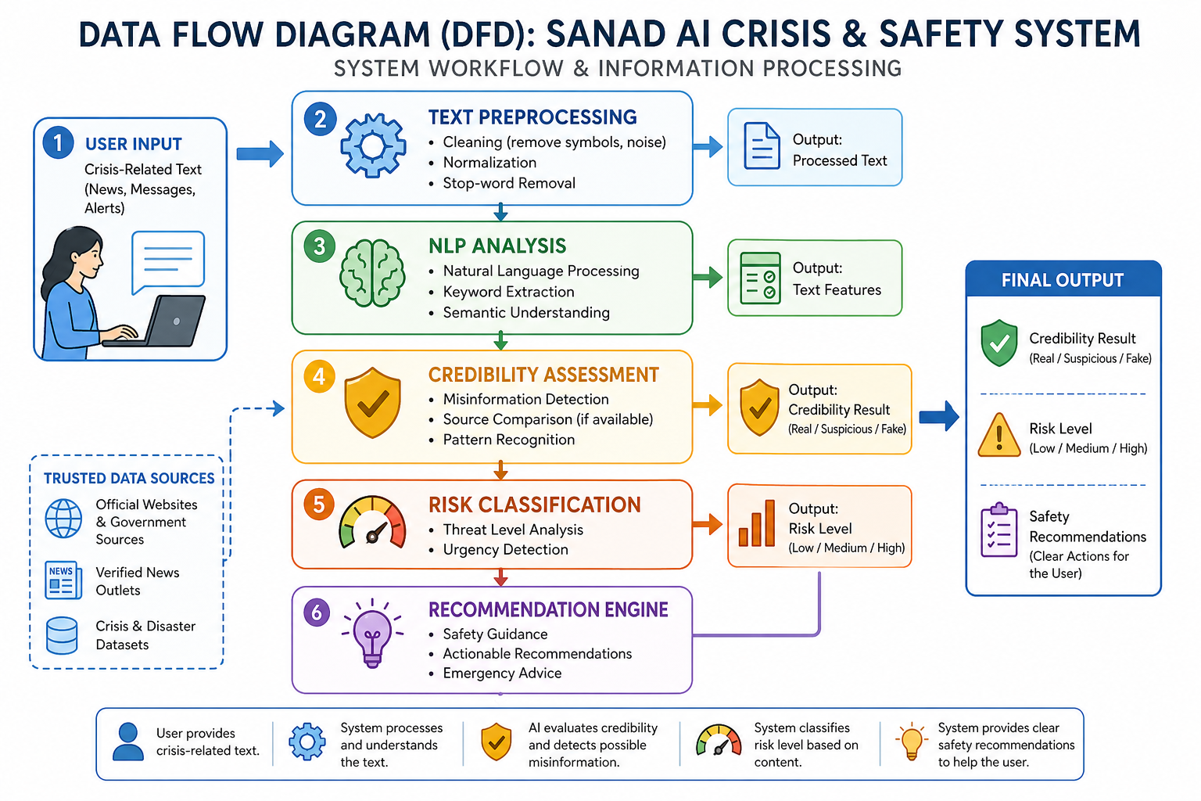AI Model (if applicable):  Model Type:  Natural Language Processing (NLP) Model with Machine Learning Classification  Input Data:  • User-entered crisis-related text  • News articles  • Alerts and messages  • Crisis-related datasets  • Extracted text features and embeddings  Output:  • Credibility Classification:  - Real  - Suspicious  - Fake  • Risk Classification:  - Low  - Medium  - High  • Safety Recommendations:  - Clear and structured actions for users  5. Tools, Software & Resources  Software & Programming Languages:  • Python  • JavaScript  • Dart  • Flutter  • Visual Studio Code  Tools / Platforms:  • Flutter SDK  • Android Studio  • Xcode  • Firebase  • Git & GitHub  • TensorFlow Lite  • NLP Libraries (NLTK, Scikit-learn)  • Flask or Django  Dataset(s):  • Public disaster datasets  • Earthquake and flood datasets  • Public health emergency datasets  • Fake news and misinformation datasets  • Verified news sources for comparison and validation  Additional Resources:  • TensorFlow Lite for mobile AI deployment  • NLP libraries such as NLTK and Scikit-learn  • Research papers on misinformation detection  • Trusted crisis information databases  6. Development Environment Setup  Tools Installed:  • Python  • Visual Studio Code  • Flutter SDK  • Android Studio  • Git & GitHub  • Firebase  • NLTK  • Scikit-learn  • Pandas  Setup Steps:  • Install Flutter SDK and configure environment variables  • Install Android Studio and create an emulator  • Install Python and Visual Studio Code  • Set up a Python virtual environment  • Install required AI and NLP libraries  • Develop the backend using Flask or Django  • Create the Flutter mobile interface  • Connect frontend and backend using APIs  • Test the application on emulator and mobile devices  Initial Code / Prototype:  The initial prototype consists of a basic mobile interface for entering crisis-related information and receiving analysis results. A Python-based NLP model processes the input text and returns credibility classifications, risk levels, and safety recommendations through API communication between the frontend and backend systems.  7. Planning & Progress Documentation  Key Decisions Made:  • The project focuses on misinformation detection and crisis safety analysis  • A mobile application was selected to support Android and iOS devices  • NLP-based machine learning models were chosen for credibility assessment  • The system combines credibility analysis with safety recommendations  • Flutter was selected for cross-platform development  Challenges Faced:  • Finding reliable crisis-related datasets  • Improving misinformation detection accuracy  • Converting AI analysis into simple recommendations  • Designing a user-friendly emergency interface  • Coordinating project tasks among team members  Solutions Applied:  • Combined multiple datasets to improve training quality  • Began with simple machine learning models before expanding  • Applied rule-based recommendation generation  • Focused on clean and accessible UI design  • Distributed responsibilities among team members  Progress Summary:  • Project idea finalized  • Research completed  • System architecture completed  • Flowcharts and data flow diagrams completed  • Tools and technologies selected  • Team responsibilities assigned  • Initial documentation completed  • Project proposal prepared for submission  8. Project Timeline (Gantt Chart)  Key Deadlines:  • Week 2 – Finalize project idea  • Week 5 – Submit project proposal  • Week 8 – Complete system design and planning  • Term 1 Week 4 – Complete development phase  • Term 1 Week 5 – Complete testing and debugging  • Term 1 Week 7 – Final presentation and deployment  Supervisor Check-ins:  • Weekly meetings with Ms. Dina Sarris  • Proposal review before submission  • Design review during planning phase  • Development progress reviews  • Final testing and presentation approval  Gantt Chart:  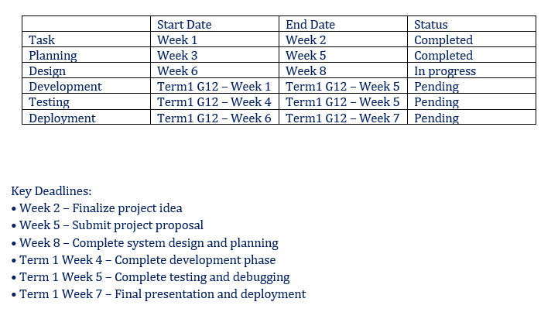  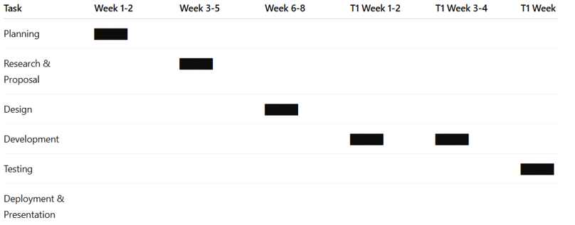  9. Final Notes  Additional Comments:  This project aims to create a practical and intelligent crisis support system using artificial intelligence and Natural Language Processing technologies. SANAD is designed to help users identify trustworthy information, understand crisis risks, and receive clear safety guidance during emergencies.  Throughout development, the team will continue improving the accuracy, usability, and reliability of the system through testing and evaluation. The project also provides valuable experience in AI development, mobile application design, teamwork, problem-solving, and software engineering practices.  SANAD has the potential to support safer decision-making during crises by reducing the impact of misinformation and providing accessible, structured guidance when users need it most.

Section2- Grade 12



G12 Term 1 overview

Welcome to Term 1 of your CAI Capstone Project!
This term focuses on turning your approved plan into a fully working computing or AI solution. You will develop, test, improve, and finalize your project while applying your programming, problem-solving, and AI skills.
With support from your supervisor, you will manage your time, document your progress, solve technical challenges, and work effectively as a team.
At the end of the term, you will present your project at the Capstone Showcase, demonstrating your solution and reflecting on what you learned. This is your opportunity to showcase your skills, creativity, and innovation.

G12 Term 1- Project Implementation Phase

Term 1 Weekly Plan: Project Production, Testing and Presentation

Week 1–2: Project Development Begins
- Start developing your approved project under the guidance of your supervisor.
- Set up your development environment and project structure.
- Begin coding, building AI models, or integrating system components based on your plan.
- Create system diagrams, flowcharts, UI designs, or architecture diagrams to guide development.
- Conduct initial testing and debug early issues.
Remember:
Take screenshots, screen recordings, or photos of your progress and keep clear notes in your project log. These will serve as evidence of your work.

Week 3–4: Project Development and Testing
- Continue development, coding, and system integration under supervisor guidance.
- Test individual features and AI components to ensure functionality, accuracy, and efficiency.
- Debug issues and refine your solution based on testing results.
- Begin drafting your project report, including methodology, system design, tools used, and problem-solving steps.
- Update your Gantt chart to track tasks, milestones, and progress.
Remember:
Continue documenting your work with screenshots, recordings, and notes at every stage to show your development process.

Week 5 – Capstone Project Showcase: Finalization and Presentation
- Complete the final development of your project and ensure all features work as planned.
- Finalize your project report, including objectives, methodology, system design, results, challenges, solutions, and lessons learned.
- Prepare your presentation materials: slides, live demo setup, visuals, and key talking points.
- Practice presenting and demonstrating your solution under supervisor guidance.
- Present your project at the Capstone Showcase, highlighting:
- The problem your project solves and its purpose.
- How your system works and any AI or technical innovations.
- Testing results and evaluation outcomes.
- What you learned and possible future improvements.
Remember:
Ensure all screenshots, recordings, photos, and documentation are organized and ready, as they form part of your project evidence.

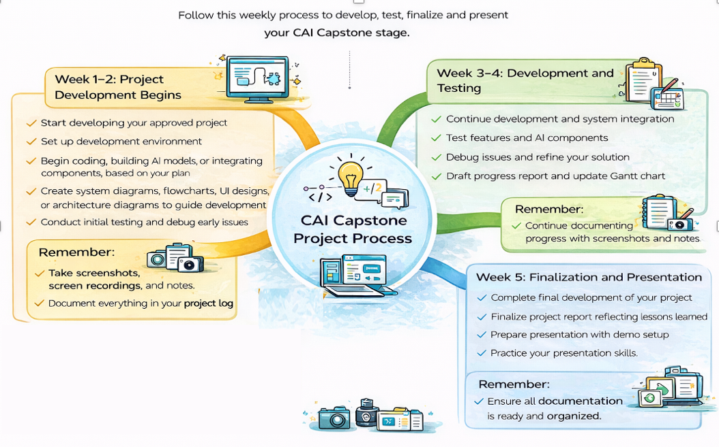

G12 Learner evidence

Appendix

Appendix A- Recommended Technology Resources
The following tools, platforms, and resources are recommended for use in CAI Capstone Projects.
Students should select technologies that match their project goals, technical skills, and supervisor guidance.
The use of modern AI tools is encouraged, as they are used ethically and responsibly.

1- Core Programming & Development Tools
Recommended for all CAI projects.
Category | Recommended Tools
Coding IDEs | Visual Studio Code, PyCharm, Jupyter Notebook, Google Colab, Replit
Programming Languages | Python, JavaScript, SQL
Version Control | GitHub

2- AI & Machine Learning Tools
Used for AI-based solutions and intelligent systems.
Category | Recommended Tools
AI Frameworks | TensorFlow, PyTorch, Scikit-learn, Keras
Computer Vision | OpenCV, MediaPipe, YOLO
NLP & LLMs | OpenAI API, Hugging Face Transformers, IBM Watson
GenAI Tools | ChatGPT, Microsoft Copilot, Google Gemini

3- Web, App & Interface Development
For projects requiring user interaction.
Category | Recommended Tools
UI/UX Design | Figma, Adobe XD, Canva
Web Frameworks | Streamlit, Gradio, Flask, FastAPI, React
Backend & Database | Firebase, SQL Databases

4- Data Science & Analytics
For data-driven and AI training projects.
Category | Recommended Tools
Data Processing | Pandas, NumPy
Visualization | Matplotlib, Plotly, Power BI, Tableau Public
Data Sources | Kaggle, UCI Repository, Hugging Face Datasets

5- Automation & Agentic AI (Advanced Projects)
Recommended for advanced teams.
Category | Recommended Tools
Automation | n8n, Zapier
AI Agents | LangChain, CrewAI, AutoGen

6- Cloud & Deployment Platforms
For hosting and demonstrating final projects.
Category | Recommended Tools
Cloud Platforms | AWS Educate, Google Cloud, Microsoft Azure
Deployment | Render, Railway, GitHub Pages

Appendix B- Suggested Hardware Component
This matrix helps students select suitable hardware components for building AI, IoT, automation, robotics, or smart system prototypes. Hardware selection should always be discussed with the supervisor before implementation.

1- Core Computing & Development Boards

Hardware Component | Primary Use | Project Examples | Skill Level | Notes
Arduino Uno / Nano | Sensor control & embedded systems | Smart sensors, automation prototypes | Beginner | Best for hardware control (not heavy AI processing)
Raspberry Pi | Edge computing, AI processing, IoT systems | Smart home, AI vision, automation systems | Intermediate | Supports Python, AI libraries, camera modules
ESP32 / ESP8266 | IoT & wireless communication | IoT monitoring systems, smart devices | Intermediate | Built-in WiFi & Bluetooth
Jetson Nano (NVIDIA) | AI edge computing | Computer vision, real-time AI projects | Advanced | Suitable for deep learning applications

2- AI Vision & Camera Modules

Hardware Component | Primary Use | Project Examples | Skill Level | Notes
USB Webcam | Basic computer vision | AI detection prototypes | Beginner | Easy integration with Python/OpenCV
Raspberry Pi Camera Module | Computer vision & image capture | Object detection, smart surveillance | Intermediate | Works directly with Raspberry Pi
AI Camera / Smart Vision Camera | AI-based visual recognition | Smart monitoring, AI inspection | Advanced | Supports edge AI processing

3- Sensors (IoT & Smart Systems)

Hardware Component | Primary Use | Project Examples | Notes
Temperature & Humidity Sensor | Environmental monitoring | Smart agriculture, smart rooms | Simple data collection
Ultrasonic Sensor | Distance detection | Robotics, smart parking | Common for automation projects
Motion (PIR) Sensor | Movement detection | Smart security systems | Easy integration
Light Sensor (LDR) | Light level detection | Smart lighting systems | Low-cost and simple
Gas / Air Quality Sensor | Environmental AI projects | Smart safety systems | Useful for real-world impact projects

4- Robotics & Automation Components

Hardware Component | Primary Use | Project Examples | Skill Level | Notes
Servo Motors | Controlled movement | Robotic arms, smart mechanisms | Beginner | Easy with Arduino
DC Motors + Motor Driver | Movement systems | Smart vehicles, automation | Intermediate | Requires motor control logic
Robotic Kit | Robotics prototyping | Autonomous robot projects | Intermediate | Combine with sensors + AI
Humanoid Robot Kits | AI interaction projects | Educational robotics | Advanced | Optional for advanced teams

5- Drone & Autonomous Systems

Hardware Component | Primary Use | Project Examples | Skill Level | Notes
Programmable Drone | Autonomous systems | AI navigation, smart inspection | Advanced | Requires safety supervision
Drone Camera Module | Aerial data collection | Vision-based AI projects | Advanced | Combine with AI models

Appendix C- Suggested AI tools & Technology Stack

1- AI Tools Matrix (based on the project type)

Project Type | Suggested Tools
AI Chatbot / Assistant | Python, OpenAI API, Streamlit, LangChain
Data Analysis Project | Python, Pandas, Power BI, Jupyter
Computer Vision Project | Python, OpenCV, YOLO, TensorFlow
Web-Based AI App | React / Streamlit, Flask, AI APIs
Mobile AI App | Swift, CoreML, AI APIs
Automation / Smart Workflow | n8n, AI APIs, Python

2- Technology Stack (based on the project type)

Project Category | Suggested Stack
AI Assistant | Python + OpenAI API + Streamlit
Smart Data Dashboard | Python + Power BI + Pandas
AI Vision System | OpenCV + TensorFlow + Python
Educational AI Tool | Python + Gradio + Hugging Face
Smart Automation System | n8n + AI APIs
AI Web Platform | React + FastAPI + Cloud Deployment

